**SQL-Question Bank**

**1.What does**UNION**do? What is the difference between**UNION**and**UNION ALL**?**

UNION merges the contents of two structurally-compatible tables into a single combined table. The difference between UNION and UNION ALL is that UNION will omit duplicate records whereas UNION ALL will include duplicate records.

It is important to note that the performance of UNION ALL will typically be better than UNION, since UNION requires the server to do the additional work of removing any duplicates. So, in cases where is certain that there will not be any duplicates, or where having duplicates is not a problem, use of UNION ALL would be recommended for performance reasons.

**2.List and explain the different types of**JOIN**clauses supported in ANSI-standard SQL.**

ANSI-standard SQL specifies five types of JOIN clauses as follows:

* INNER JOIN (a.k.a. “simple join”): Returns all rows for which there is at least one match in BOTH tables. *This is the default type of join if no specific JOIN type is specified.*
* LEFT JOIN (or LEFT OUTER JOIN): Returns all rows from the left table, and the matched rows from the right table; i.e., the results will contain *all* records from the left table, even if the JOIN condition doesn’t find any matching records in the right table. This means that if the ON clause doesn’t match any records in the right table, the JOIN will still return a row in the result for that record in the left table, but with NULL in each column from the right table.
* RIGHT JOIN (or RIGHT OUTER JOIN): Returns all rows from the right table, and the matched rows from the left table. This is the exact opposite of a LEFT JOIN; i.e., the results will contain *all* records from the right table, even if the JOIN condition doesn’t find any matching records in the left table. This means that if the ON clause doesn’t match any records in the left table, the JOIN will still return a row in the result for that record in the right table, but with NULL in each column from the left table.
* FULL JOIN (or FULL OUTER JOIN): Returns all rows for which there is a match in EITHER of the tables. Conceptually, a FULL JOIN combines the effect of applying both a LEFT JOIN and a RIGHT JOIN; i.e., its result set is equivalent to performing a UNION of the results of left and right outer queries.
* CROSS JOIN: Returns all records where each row from the first table is combined with each row from the second table (i.e., returns the Cartesian product of the sets of rows from the joined tables). Note that a CROSS JOIN can either be specified using the CROSS JOIN syntax (“explicit join notation”) or (b) listing the tables in the FROM clause separated by commas without using a WHERE clause to supply join criteria (“implicit join notation”).

**3. Given the following tables:**

sql> SELECT * FROM runners;

+----+--------------+

| id | name |

+----+--------------+

| 1 | John Doe |

| 2 | Jane Doe |

| 3 | Alice Jones |

| 4 | Bobby Louis |

| 5 | Lisa Romero |

+----+--------------+

sql> SELECT * FROM races;

+----+----------------+-----------+

| id | event | winner_id |

+----+----------------+-----------+

| 1 | 100 meter dash | 2 |

| 2 | 500 meter dash | 3 |

| 3 | cross-country | 2 |

| 4 | triathalon | NULL |

+----+----------------+-----------+

**4. What will be the result of the query below?**

SELECT * FROM runners WHERE id NOT IN (SELECT winner_id FROM races)

**Explain your answer and also provide an alternative version of this query that will avoid the issue that it exposes.**

Surprisingly, given the sample data provided, the result of this query will be an empty set. The reason for this is as follows: If the set being evaluated by the SQL NOT IN condition contains *any* values that are null, then the outer query here will return an empty set, even if there are many runner ids that match winner_ids in the races table.

Knowing this, a query that avoids this issue would be as follows:

SELECT * FROM runners WHERE id NOT IN (SELECT winner_id FROM races WHERE winner_id IS NOT null)

Note, this is assuming the standard SQL behaviour that you get without modifying the default ANSI_NULLS setting.

**5. How to select UNIQUE records from a table using a SQL Query?**

**Consider below EMPLOYEE table as the source data**

CREATE TABLE EMPLOYEE (

EMPLOYEE_ID NUMBER(6,0),

NAME VARCHAR2(20),

SALARY NUMBER(8,2)

);

INSERT INTO EMPLOYEE(EMPLOYEE_ID,NAME,SALARY) VALUES(100,'Jennifer',4400);

INSERT INTO EMPLOYEE(EMPLOYEE_ID,NAME,SALARY) VALUES(100,'Jennifer',4400);

INSERT INTO EMPLOYEE(EMPLOYEE_ID,NAME,SALARY) VALUES(101,'Michael',13000);

INSERT INTO EMPLOYEE(EMPLOYEE_ID,NAME,SALARY) VALUES(101,'Michael',13000);

INSERT INTO EMPLOYEE(EMPLOYEE_ID,NAME,SALARY) VALUES(101,'Michael',13000);

INSERT INTO EMPLOYEE(EMPLOYEE_ID,NAME,SALARY) VALUES(102,'Pat',6000);

INSERT INTO EMPLOYEE(EMPLOYEE_ID,NAME,SALARY) VALUES(102,'Pat',6000);

INSERT INTO EMPLOYEE(EMPLOYEE_ID,NAME,SALARY) VALUES(103,'Den',11000);

SELECT * FROM EMPLOYEE;

| **EMPLOYEE_ID** | **NAME** | **SALARY** |
| --- | --- | --- |
| 100 | Jennifer | 4400 |
| 100 | Jennifer | 4400 |
| 101 | Michael | 13000 |
| 101 | Michael | 13000 |
| 101 | Michael | 13000 |
| 102 | Pat | 6000 |
| 102 | Pat | 6000 |
| 103 | Den | 11000 |

**METHOD-1: Using GROUP BY Function**

**GROUP BY clause is used with a SELECT statement to collect data from multiple records and group the results by one or more columns. The GROUP BY clause returns one row per group. By applying GROUP BY function on all the source columns, unique records can be queried from the table.**

Below is the query to fetch the unique records using GROUP BY function.

**Query:**

SELECT EMPLOYEE_ID,

NAME,

SALARY

FROM EMPLOYEE

GROUP BY EMPLOYEE_ID, NAME, SALARY;

**Result:**

| **EMPLOYEE_ID** | **NAME** | **SALARY** |
| --- | --- | --- |
| 100 | Jennifer | 4400 |
| 101 | Michael | 13000 |
| 102 | Pat | 6000 |
| 103 | Den | 11000 |

**METHOD-2: Using ROW_NUMBER Analytic Function**

**The ROW_NUMBER Analytic function is used to provide consecutive numbering of the rows in the result by the ORDER selected for each PARTITION specified in the OVER clause. It will assign the value 1 for the first row and increase the number of the subsequent rows.**

Using ROW_NUMBER Analytic function, assign row numbers to each unique set of records.

**Query:**

SELECT EMPLOYEE_ID,

NAME,

SALARY,

ROW_NUMBER() OVER(PARTITION BY EMPLOYEE_ID,NAME,SALARY ORDER BY EMPLOYEE_ID) AS ROW_NUMBER

FROM EMPLOYEE;

**Result:**

| **EMPLOYEE_ID** | **NAME** | **SALARY** | **ROW_NUMBER** |
| --- | --- | --- | --- |
| 100 | Jennifer | 4400 | 1 |
| 100 | Jennifer | 4400 | 2 |
| 101 | Michael | 13000 | 1 |
| 101 | Michael | 13000 | 2 |
| 101 | Michael | 13000 | 3 |
| 102 | Pat | 6000 | 1 |
| 102 | Pat | 6000 | 2 |
| 103 | Den | 11000 | 1 |

Once row numbers are assigned, by querying the rows with row number 1 will give the unique records from the table.

**Query:**

SELECT EMPLOYEE_ID, NAME, SALARY

FROM( SELECT

EMPLOYEE_ID,

NAME,

SALARY,

ROW_NUMBER() OVER(PARTITION BY EMPLOYEE_ID,NAME,SALARY ORDER BY EMPLOYEE_ID) AS ROW_NUMBER

FROM EMPLOYEE)

WHERE ROW_NUMBER = 1;

**Result:**

| **EMPLOYEE_ID** | **NAME** | **SALARY** |
| --- | --- | --- |
| 101 | Michael | 13000 |
| 100 | Jennifer | 4400 |
| 102 | Pat | 6000 |
| 103 | Den | 11000 |

## **6. How to delete DUPLICATE records from a table using a SQL Query?**

Consider the same EMPLOYEE table as source discussed in previous question

**STEP-1: Using ROW_NUMBER Analytic function, assign row numbers to each unique set of records. Select ROWID of the rows along with the source columns**

**Query:**

SELECT ROWID,

EMPLOYEE_ID,

NAME,SALARY,

ROW_NUMBER() OVER(PARTITION BY EMPLOYEE_ID,NAME,SALARY ORDER BY EMPLOYEE_ID) AS ROW_NUMBER

FROM EMPLOYEE;

**Result:**

| **ROWID** | **EMPLOYEE_ID** | **NAME** | **SALARY** | **ROW_NUMBER** |
| --- | --- | --- | --- | --- |
| AAASnBAAEAAACrWAAA | 100 | Jennifer | 4400 | 1 |
| AAASnBAAEAAACrWAAB | 100 | Jennifer | 4400 | 2 |
| AAASnBAAEAAACrWAAC | 101 | Michael | 13000 | 1 |
| AAASnBAAEAAACrWAAD | 101 | Michael | 13000 | 2 |
| AAASnBAAEAAACrWAAE | 101 | Michael | 13000 | 3 |
| AAASnBAAEAAACrWAAF | 102 | Pat | 6000 | 1 |
| AAASnBAAEAAACrWAAG | 102 | Pat | 6000 | 2 |
| AAASnBAAEAAACrWAAH | 103 | Den | 11000 | 1 |

**STEP-2: Select ROWID of records with ROW_NUMBER > 1**

**Query:**

SELECT ROWID FROM(

SELECT ROWID,

EMPLOYEE_ID,

NAME,

SALARY,

ROW_NUMBER() OVER(PARTITION BY EMPLOYEE_ID,NAME,SALARY ORDER BY EMPLOYEE_ID) AS ROW_NUMBER

FROM EMPLOYEE)

WHERE ROW_NUMBER > 1;

**Result:**

| **ROWID** |
| --- |
| AAASnBAAEAAACrWAAB |
| AAASnBAAEAAACrWAAD |
| AAASnBAAEAAACrWAAE |
| AAASnBAAEAAACrWAAG |

**STEP-3: Delete the records from the source table using the ROWID values fetched in previous step**

**Query:**

DELETE FROM EMP WHERE ROWID IN (

SELECT ROWID FROM(

SELECT ROWID,

ROW_NUMBER() OVER(PARTITION BY EMPLOYEE_ID,NAME,SALARY ORDER BY EMPLOYEE_ID) AS ROW_NUMBER

FROM EMPLOYEE)

WHERE ROW_NUMBER > 1);

**Result:**

The table EMPLOYEE will have below records after deleting the duplicates

| **ROWID** | **EMPLOYEE_ID** | **NAME** | **SALARY** |
| --- | --- | --- | --- |
| AAASnBAAEAAACrWAAA | 100 | Jennifer | 4400 |
| AAASnBAAEAAACrWAAC | 101 | Michael | 13000 |
| AAASnBAAEAAACrWAAF | 102 | Pat | 6000 |
| AAASnBAAEAAACrWAAH | 103 | Den | 11000 |

**METHOD-2: Using ROWID and Correlated subquery**

**Correlated subquery is used for row-by-row processing. With a normal nested subquery, the inner SELECT query runs once and executes first. The returning values will be used by the main query. A correlated subquery, however, executes once for every row of the outer query. In other words, the inner query is driven by the outer query.**

In the below query, we are comparing the ROWIDs’ of the unique set of records and keeping the record with MIN ROWID and deleting all other rows.

**Query:**

DELETE FROM EMPLOYEE A WHERE ROWID > (SELECT MIN(ROWID) FROM EMPLOYEE B WHERE B.EMPLOYEE_ID = A.EMPLOYEE_ID );

**Result:**

The table EMPLOYEE will have below records after deleting the duplicates

| **ROWID** | **EMPLOYEE_ID** | **NAME** | **SALARY** |
| --- | --- | --- | --- |
| AAASnBAAEAAACrWAAA | 100 | Jennifer | 4400 |
| AAASnBAAEAAACrWAAC | 101 | Michael | 13000 |
| AAASnBAAEAAACrWAAF | 102 | Pat | 6000 |
| AAASnBAAEAAACrWAAH | 103 | Den | 11000 |

The opposite of above discussed case can be implemented by keeping the record with MAX ROWID from the unique set of records and delete all other duplicates by executing below query.

**Query:**

DELETE FROM EMPLOYEE A WHERE ROWID < (SELECT MAX(ROWID) FROM EMPLOYEE B WHERE B.EMPLOYEE_ID = A.EMPLOYEE_ID );

**Result:**

The table EMPLOYEE will have below records after deleting the duplicates

| **ROWID** | **EMPLOYEE_ID** | **NAME** | **SALARY** |
| --- | --- | --- | --- |
| AAASnBAAEAAACrWAAA | 100 | Jennifer | 4400 |
| AAASnBAAEAAACrWAAC | 101 | Michael | 13000 |
| AAASnBAAEAAACrWAAF | 102 | Pat | 6000 |
| AAASnBAAEAAACrWAAH | 103 | Den | 11000 |

**7. How to read TOP 5 records from a table using a SQL query?**

**Consider below table DEPARTMENTS as the source data**

CREATE TABLE Departments(

Department_ID number,

Department_Name varchar(50);

INSERT INTO DEPARTMENTS VALUES('10','Administration');

INSERT INTO DEPARTMENTS VALUES('20','Marketing');

INSERT INTO DEPARTMENTS VALUES('30','Purchasing');

INSERT INTO DEPARTMENTS VALUES('40','Human Resources');

INSERT INTO DEPARTMENTS VALUES('50','Shipping');

INSERT INTO DEPARTMENTS VALUES('60','IT');

INSERT INTO DEPARTMENTS VALUES('70','Public Relations');

INSERT INTO DEPARTMENTS VALUES('80','Sales');

SELECT * FROM Departments;

| **DEPARTMENT_ID** | **DEPARTMENT_NAME** |
| --- | --- |
| 10 | Administration |
| 20 | Marketing |
| 30 | Purchasing |
| 40 | Human Resources |
| 50 | Shipping |
| 60 | IT |
| 70 | Public Relations |
| 80 | Sales |

**ROWNUM is a “Pseudocolumn” that assigns a number to each row returned by a query indicating the order in which Oracle selects the row from a table. The first row selected has a ROWNUM of 1, the second has 2, and so on.**

**Query:**

SELECT * FROM Departments WHERE ROWNUM <= 5;

**Result:**

| **DEPARTMENT_ID** | **DEPARTMENT_NAME** |
| --- | --- |
| 10 | Administration |
| 20 | Marketing |
| 30 | Purchasing |
| 40 | Human Resources |
| 50 | Shipping |

**8. How to read LAST 5 records from a table using a SQL query?**

Consider the same DEPARTMENTS table as the source discussed in the previous question.

In order to select the last 5 records we need to find (**count of total number of records – 5***)* which gives the count of records from first to last but 5 records. Using the MINUS function we can compare **all records from DEPARTMENTS table** with **records from first to last but 5 from DEPARTMENTS table**which give the last 5 records of the table as result.

**MINUS operator is used to return all rows in the first SELECT statement that are not present in the second SELECT statement.**

**Query:**

SELECT * FROM Departments

MINUS

SELECT * FROM Departments WHERE ROWNUM <= (SELECT COUNT(*)-5 FROM Departments);

**Result:**

| **DEPARTMENT_ID** | **DEPARTMENT_NAME** |
| --- | --- |
| 40 | Human Resources |
| 50 | Shipping |
| 60 | IT |
| 70 | Public Relations |
| 80 | Sales |

**9. What is the result of Normal Join, Left Outer Join, Right Outer Join and Full Outer Join between the tables A & B?**

**Table_A**

| **COL** |
| --- |
| 1 |
| 1 |
| 0 |
| null |

**Table_B**

| **COL** |
| --- |
| 1 |
| 0 |
| null |
| null |

**Normal Join**:

**Normal Join or Inner Join is the most common type of join. It returns the rows that are exact match between both the tables.**

The following Venn diagram illustrates a Normal join when combining two result sets:

**Query:**

SELECT a.COL as A,

b.COL as B

FROM TABLE_A a JOIN TABLE_B b

ON a.COL = b.COL;

**Result:**

| **A** | **B** |
| --- | --- |
| 1 | 1 |
| 1 | 1 |
| 0 | 0 |

**Left Outer Join**:

**The Left Outer Join returns all the rows from the left table and only the matching rows from the right table. If there is no matching row found from the right table, the left outer join will have NULL values for the columns from the right table.**

The following Venn diagram illustrates a Left join when combining two result sets:

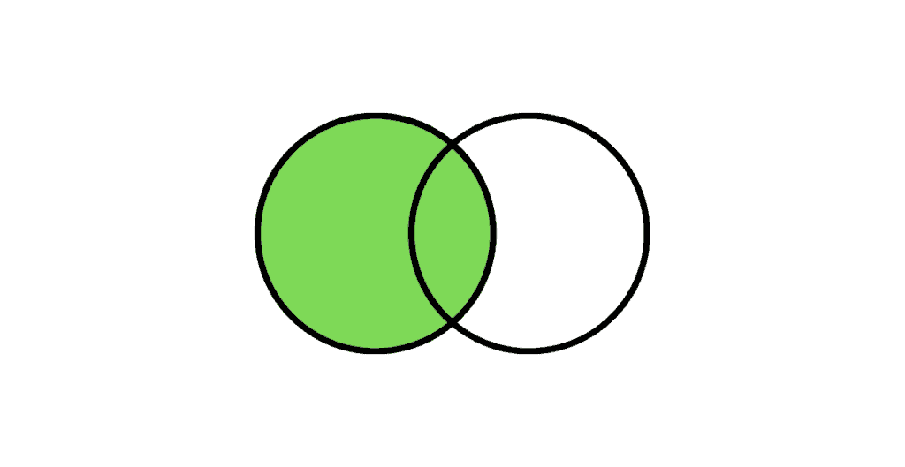

**Query:**

SELECT a.COL as A,

b.COL as B

FROM TABLE_A a LEFT OUTER JOIN TABLE_B b

ON a.COL = b.COL;

**Result:**

| **A** | **B** |
| --- | --- |
| 1 | 1 |
| 1 | 1 |
| 0 | 0 |
| NULL | NULL |

**Right Outer Join:**

**The Right Outer Join returns all the rows from the right table and only the matching rows from the left table. If there is no matching row found from the left table, the right outer join will have NULL values for the columns from the left table.**

The following Venn diagram illustrates a Right join when combining two result sets:

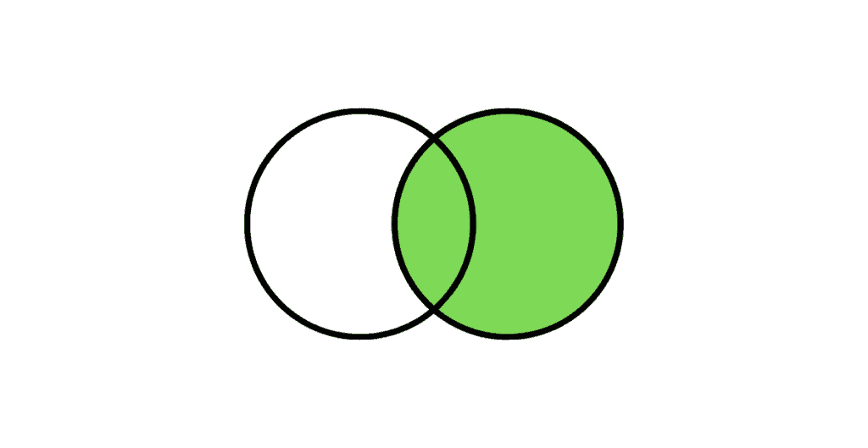

**Query:**

SELECT a.COL as A,

b.COL as B

FROM TABLE_A a RIGHT OUTER JOIN TABLE_B b

ON a.COL = b.COL;

**Result:**

| **A** | **B** |
| --- | --- |
| 1 | 1 |
| 1 | 1 |
| 0 | 0 |
| NULL | NULL |
| NULL | NULL |

**Full Outer Join:**

**The Full Outer Join returns all the rows from both the right table and the left table. If there is no matching row found, the missing side columns will have NULL values.**

The following Venn diagram illustrates a Full join when combining two result sets:

**Query:**

SELECT a.COL as A,

b.COL as B

FROM TABLE_A a FULL OUTER JOIN TABLE_B b

ON a.COL = b.COL;

**Result:**

| **A** | **B** |
| --- | --- |
| 1 | 1 |
| 1 | 1 |
| 0 | 0 |
| NULL | NULL |
| NULL | NULL |
| NULL | NULL |

***NOTE:****NULL do not match with NULL*

**10. How to find the employee with a second MAX Salary using a SQL query?**

**Consider below EMPLOYEES table as the source data**

CREATE TABLE Employees(

EMPLOYEE_ID NUMBER(6,0),

NAME VARCHAR2(20 BYTE),

SALARY NUMBER(8,2)

);

INSERT INTO EMPLOYEES(EMPLOYEE_ID,NAME,SALARY) VALUES(100,'Jennifer',4400);

INSERT INTO EMPLOYEES(EMPLOYEE_ID,NAME,SALARY) VALUES(101,'Michael',13000);

INSERT INTO EMPLOYEES(EMPLOYEE_ID,NAME,SALARY) VALUES(102,'Pat',6000);

INSERT INTO EMPLOYEES(EMPLOYEE_ID,NAME,SALARY) VALUES(103,'Den', 11000);

INSERT INTO EMPLOYEES(EMPLOYEE_ID,NAME,SALARY) VALUES(104,'Alexander',3100);

INSERT INTO EMPLOYEES(EMPLOYEE_ID,NAME,SALARY) VALUES(105,'Shelli',2900);

INSERT INTO EMPLOYEES(EMPLOYEE_ID,NAME,SALARY) VALUES(106,'Sigal',2800);

INSERT INTO EMPLOYEES(EMPLOYEE_ID,NAME,SALARY) VALUES(107,'Guy',2600);

INSERT INTO EMPLOYEES(EMPLOYEE_ID,NAME,SALARY) VALUES(108,'Karen',2500);

SELECT * FROM Employees;

| **EMPLOYEE_ID** | **NAME** | **SALARY** |
| --- | --- | --- |
| 100 | Jennifer | 4400 |
| 101 | Michael | 13000 |
| 102 | Pat | 6000 |
| 103 | Den | 11000 |
| 104 | Alexander | 3100 |
| 105 | Shelli | 2900 |
| 106 | Sigel | 2800 |
| 107 | Guy | 2600 |
| 108 | Karen | 2500 |

**METHOD-1: Without using SQL Analytic Functions**

In order to find the second MAX salary, employee records with MAX salary need to be eliminated. It can be achieved by using the below SQL query.

**Query:**

SELECT MAX(salary) AS salary FROM Employees WHERE salary NOT IN (

SELECT MAX(salary) AS salary FROM Employees);

**Result:**

| **SALARY** |
| --- |
| 11000 |

The above query only gives the second MAX salary value. In order to fetch the entire employee record with the second MAX salary we need to do a self-join on the Employee table based on Salary value.

**Query:**

WITH

TEMP AS(

SELECT MAX(salary) AS salary FROM Employees WHERE salary NOT IN (

SELECT MAX(salary) AS salary FROM Employees)

)

SELECT a.* FROM Employees a JOIN TEMP b on a.salary = b.salary

**Result:**

| **EMPLOYEE_ID** | **NAME** | **SALARY** |
| --- | --- | --- |
| 103 | Den | 11000 |

**METHOD-2: Using SQL Analytic Functions**

**Query:**

**The DENSE_RANK is an analytic function that calculates the rank of a row in an ordered set of rows starting from 1. Unlike the RANK function, the DENSE_RANK function returns rank values as consecutive integers.**

SELECT Employee_Id,

Name,

Salary

FROM(

SELECT Employees.*,

DENSE_RANK() OVER(ORDER BY Salary DESC) as SALARY_RANK

FROM Employees)

WHERE SALARY_RANK =2

**Result:**

| **EMPLOYEE_ID** | **NAME** | **SALARY** |
| --- | --- | --- |
| 103 | Den | 11000 |

***By replacing the value of SALARY_RANK, any highest salary rank can be found easily.***

**11. How to find the employee with the third MAX Salary using a SQL query without using Analytic Functions?**

**Consider the same EMPLOYEES table as source discussed in previous question**

In order to find the third MAX salary, we need to eliminate the top 2 salary records. But we cannot use the same method we used for finding a second MAX salary (not a best practice). Imagine if we have to find the fifth MAX salary. We should not be writing a query with four nested sub queries.

**STEP-1:**

The approach here is to first list all the records based on Salary in the descending order with MAX salary on top and MIN salary at bottom. Next, using ROWNUM select the top 2 records.

**Query:**

SELECT salary FROM(

SELECT salary FROM Employees ORDER BY salary DESC)

WHERE ROWNUM < 3;

**Result:**

| **Salary** |
| --- |
| 13000 |
| 11000 |

**STEP-2:**

Next find the MAX salary from the EMPLOYEE table which is not one of top two salary values fetched in the earlier step.

**Query:**

SELECT MAX(salary) as salary FROM Employees WHERE salary NOT IN (

SELECT salary FROM(

SELECT salary FROM Employees ORDER BY salary DESC)

WHERE ROWNUM < 3

);

**Result:**

| **SALARY** |
| --- |
| 6000 |

**STEP-3:**

In order to fetch the entire employee record with the third MAX salary we need to do a self-join on the Employee table based on Salary value.

**Query:**

WITH

TEMP AS(

SELECT MAX(salary) as salary FROM Employees WHERE salary NOT IN (

SELECT salary FROM(

SELECT salary FROM Employees ORDER BY salary DESC)

WHERE ROWNUM < 3)

)

SELECT a.* FROM Employees a join TEMP b on a.salary = b.salary

**Result:**

| **EMPLOYEE_ID** | **NAME** | **SALARY** |
| --- | --- | --- |
| 102 | Pat | 6000 |

## 

Danny wants to use the data to answer a few simple questions about his customers, especially about their visiting patterns, how much money they’ve spent and also which menu items are their favourite. Having this deeper connection with his customers will help him deliver a better and more personalized experience for his loyal customers.

He plans on using these insights to help him decide whether he should expand the existing customer loyalty program - additionally he needs help to generate some basic datasets so his team can easily inspect the data without needing to use SQL.

Danny has provided you with a sample of his overall customer data due to privacy issues - but he hopes that these examples are enough for you to write fully functioning SQL queries to help him answer his questions!

Danny has shared with you 3 key datasets for this case study:

* sales
* menu
* members

You can inspect the entity relationship diagram and example data below.

## Example Datasets

### Table 1: sales

The sales table captures all customer_id level purchases with an corresponding order_date and product_id information for when and what menu items were ordered.

| **customer_id** | **order_date** | **product_id** |
| --- | --- | --- |
| A | 2021-01-01 | 1 |
| A | 2021-01-01 | 2 |
| A | 2021-01-07 | 2 |
| A | 2021-01-10 | 3 |
| A | 2021-01-11 | 3 |
| A | 2021-01-11 | 3 |
| B | 2021-01-01 | 2 |
| B | 2021-01-02 | 2 |
| B | 2021-01-04 | 1 |
| B | 2021-01-11 | 1 |
| B | 2021-01-16 | 3 |
| B | 2021-02-01 | 3 |
| C | 2021-01-01 | 3 |
| C | 2021-01-01 | 3 |
| C | 2021-01-07 | 3 |

### Table 2: menu

The menu table maps the product_id to the actual product_name and price of each menu item.

| **product_id** | **product_name** | **price** |
| --- | --- | --- |
| 1 | sushi | 10 |
| 2 | curry | 15 |
| 3 | ramen | 12 |

### Table 3: members

The final members table captures the join_date when a customer_id joined the beta version of the Danny’s Diner loyalty program.

| **customer_id** | **join_date** |
| --- | --- |
| A | 2021-01-07 |
| B | 2021-01-09 |

## 

Each of the following case study questions can be answered using a single SQL statement:

12.1. What is the total amount each customer spent at the restaurant?

12.2. How many days has each customer visited the restaurant?

12.3. What was the first item from the menu purchased by each customer?

12.4. What is the most purchased item on the menu and how many times was it purchased by all customers?

12.5 Which item was the most popular for each customer?

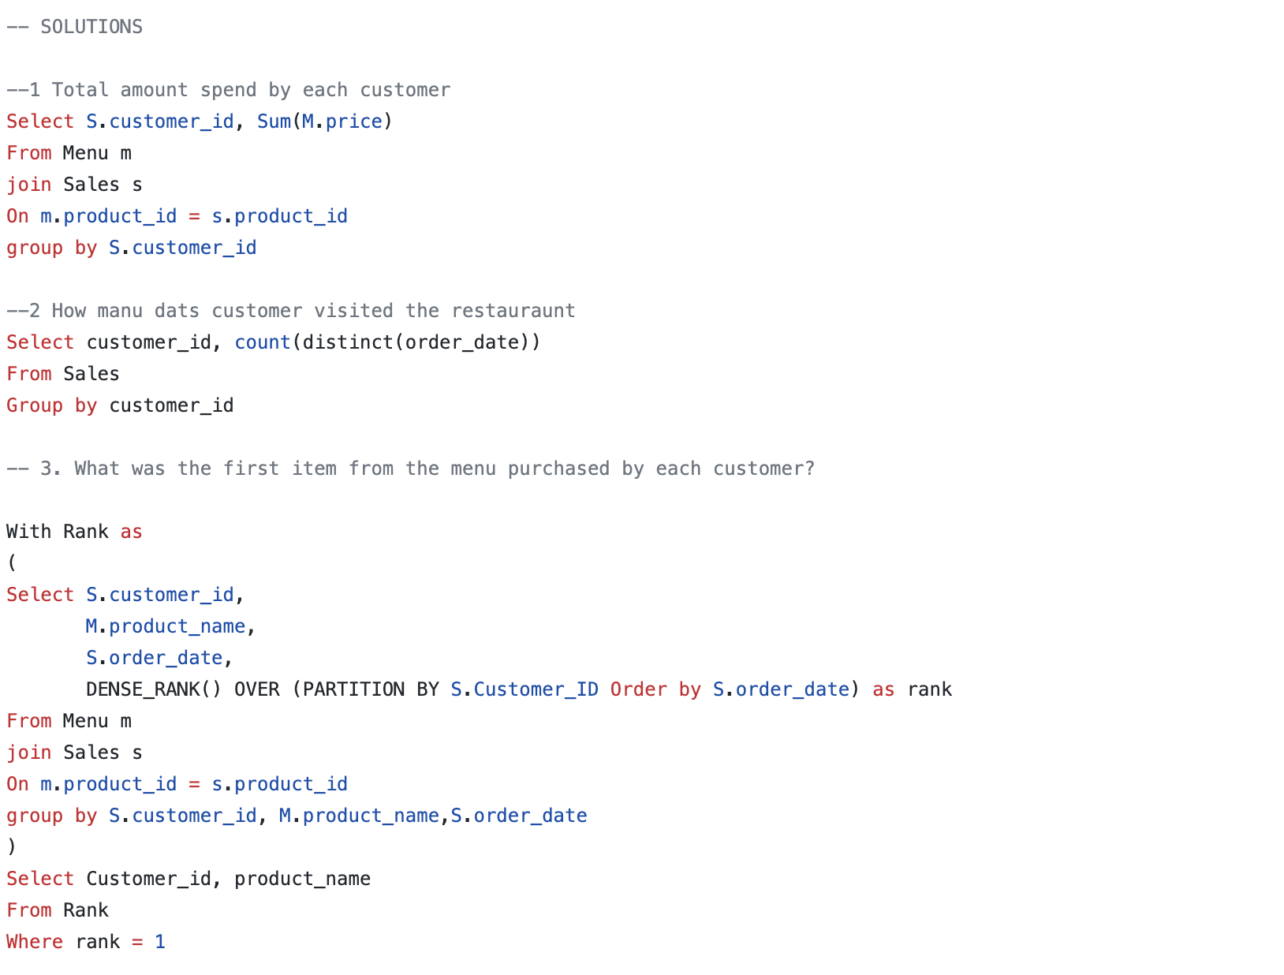

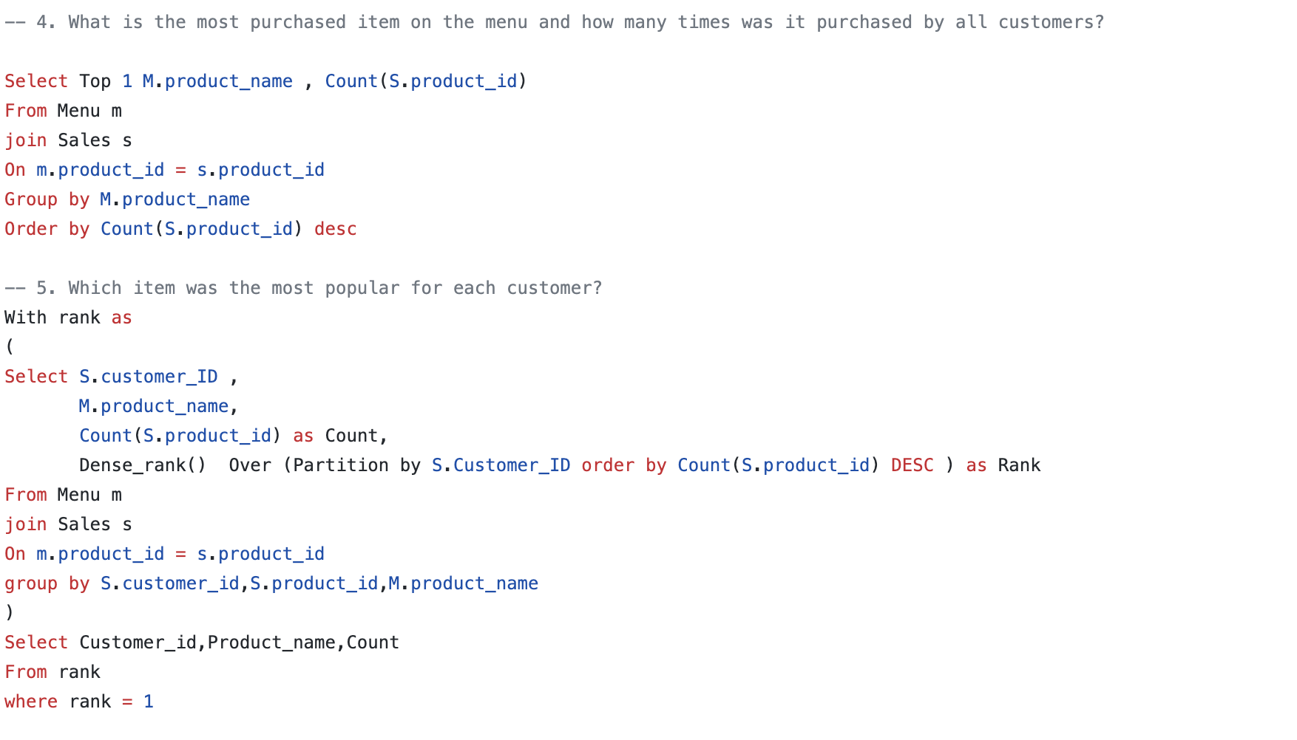

13. Did you know that over **115 million kilograms** of pizza is consumed daily worldwide???

Danny was scrolling through his Instagram feed when something really caught his eye - “80s Retro Styling and Pizza Is The Future!”

Danny was sold on the idea, but he knew that pizza alone was not going to help him get seed funding to expand his new Pizza Empire - so he had one more genius idea to combine with it - he was going to *Uberize* it - and so Pizza Runner was launched!

Danny started by recruiting “runners” to deliver fresh pizza from Pizza Runner Headquarters (otherwise known as Danny’s house) and also maxed out his credit card to pay freelance developers to build a mobile app to accept orders from customers.

### Table 1: runners

The runners table shows the registration_date for each new runner

| **runner_id** | **registration_date** |
| --- | --- |
| 1 | 2021-01-01 |
| 2 | 2021-01-03 |
| 3 | 2021-01-08 |
| 4 | 2021-01-15 |

### Table 2: customer_orders

Customer pizza orders are captured in the customer_orders table with 1 row for each individual pizza that is part of the order.

The pizza_id relates to the type of pizza which was ordered whilst the exclusions are the ingredient_id values which should be removed from the pizza and the extras are the ingredient_id values which need to be added to the pizza.

Note that customers can order multiple pizzas in a single order with varying exclusions and extras values even if the pizza is the same type!

The exclusions and extras columns will need to be cleaned up before using them in your queries.

| **order_id** | **customer_id** | **pizza_id** | **exclusions** | **extras** | **order_time** |
| --- | --- | --- | --- | --- | --- |
| 1 | 101 | 1 |  |  | 2021-01-01 18:05:02 |
| 2 | 101 | 1 |  |  | 2021-01-01 19:00:52 |
| 3 | 102 | 1 |  |  | 2021-01-02 23:51:23 |
| 3 | 102 | 2 |  | NaN | 2021-01-02 23:51:23 |
| 4 | 103 | 1 | 4 |  | 2021-01-04 13:23:46 |
| 4 | 103 | 1 | 4 |  | 2021-01-04 13:23:46 |
| 4 | 103 | 2 | 4 |  | 2021-01-04 13:23:46 |
| 5 | 104 | 1 | null | 1 | 2021-01-08 21:00:29 |
| 6 | 101 | 2 | null | null | 2021-01-08 21:03:13 |
| 7 | 105 | 2 | null | 1 | 2021-01-08 21:20:29 |
| 8 | 102 | 1 | null | null | 2021-01-09 23:54:33 |
| 9 | 103 | 1 | 4 | 1, 5 | 2021-01-10 11:22:59 |
| 10 | 104 | 1 | null | null | 2021-01-11 18:34:49 |
| 10 | 104 | 1 | 2, 6 | 1, 4 | 2021-01-11 18:34:49 |

### Table 3: runner_orders

After each order is received through the system - they are assigned to a runner - however not all orders are fully completed and can be cancelled by the restaurant or the customer.

The pickup_time is the timestamp at which the runner arrives at the Pizza Runner headquarters to pick up the freshly cooked pizzas. The distance and duration fields are related to how far and long the runner had to travel to deliver the order to the respective customer.

There are some known data issues with this table so be careful when using this in your queries - make sure to check the data types for each column in the schema SQL!

| **order_id** | **runner_id** | **pickup_time** | **distance** | **duration** | **cancellation** |
| --- | --- | --- | --- | --- | --- |
| 1 | 1 | 2021-01-01 18:15:34 | 20km | 32 minutes |  |
| 2 | 1 | 2021-01-01 19:10:54 | 20km | 27 minutes |  |
| 3 | 1 | 2021-01-03 00:12:37 | 13.4km | 20 mins | NaN |
| 4 | 2 | 2021-01-04 13:53:03 | 23.4 | 40 | NaN |
| 5 | 3 | 2021-01-08 21:10:57 | 10 | 15 | NaN |
| 6 | 3 | null | null | null | Restaurant Cancellation |
| 7 | 2 | 2020-01-08 21:30:45 | 25km | 25 mins | null |
| 8 | 2 | 2020-01-10 00:15:02 | 23.4 km | 15 minute | null |
| 9 | 2 | null | null | null | Customer Cancellation |
| 10 | 1 | 2020-01-11 18:50:20 | 10km | 10 minutes | null |

### Table 4: pizza_names

At the moment - Pizza Runner only has 2 pizzas available: the Meat Lovers or Vegetarian!

| **pizza_id** | **pizza_name** |
| --- | --- |
| 1 | Meat Lovers |
| 2 | Vegetarian |

### Table 5: pizza_recipes

Each pizza_id has a standard set of toppings which are used as part of the pizza recipe.

| **pizza_id** | **toppings** |
| --- | --- |
| 1 | 1, 2, 3, 4, 5, 6, 8, 10 |
| 2 | 4, 6, 7, 9, 11, 12 |

### Table 6: pizza_toppings

This table contains all of the topping_name values with their corresponding topping_id value

| **topping_id** | **topping_name** |
| --- | --- |
| 1 | Bacon |
| 2 | BBQ Sauce |
| 3 | Beef |
| 4 | Cheese |
| 5 | Chicken |
| 6 | Mushrooms |
| 7 | Onions |
| 8 | Pepperoni |
| 9 | Peppers |
| 10 | Salami |
| 11 | Tomatoes |
| 12 | Tomato Sauce |

## Case Study Questions

## This case study has LOTS of questions - they are broken up by area of focus including:

## Pizza Metrics

## Runner and Customer Experience

## Ingredient Optimisation

## Pricing and Ratings

## Bonus DML Challenges (DML = Data Manipulation Language)

### Pizza Metrics

13.1. How many pizzas were ordered?

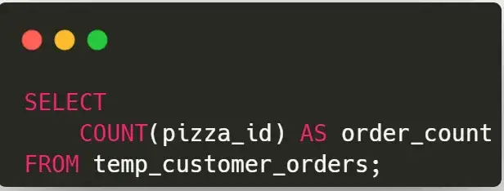

13.2. How many unique customer orders were made?

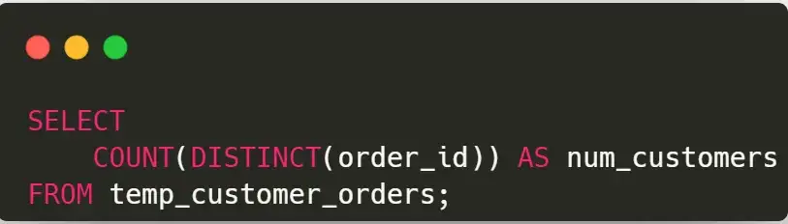

13.3. How many successful orders were delivered by each runner?

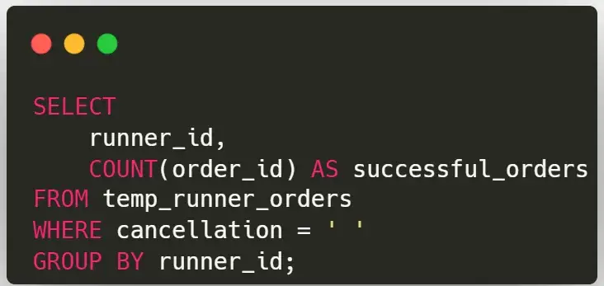

13.4. How many of each type of pizza was delivered?

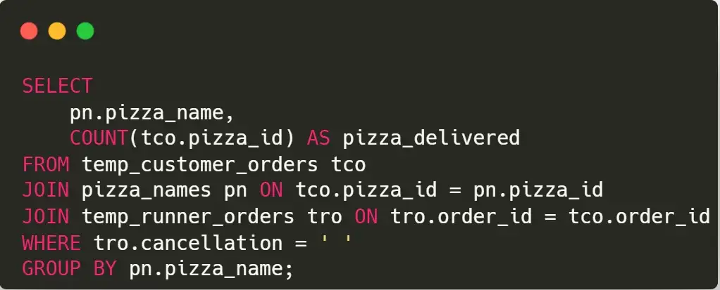

13.5. How many Vegetarian and Meatlovers were ordered by each customer?

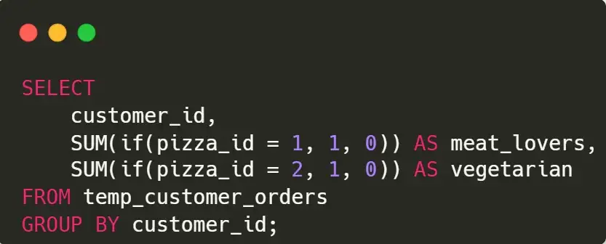

13.6. What was the maximum number of pizzas delivered in a single order?

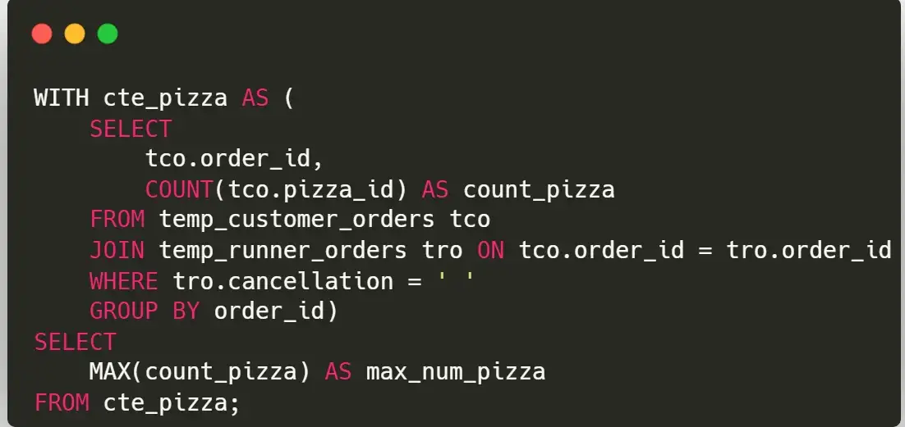

14. Subscription based businesses are super popular and Danny realised that there was a large gap in the market - he wanted to create a new streaming service that only had food related content - something like Netflix but with only cooking shows!

Danny finds a few smart friends to launch his new startup Foodie-Fi in 2020 and starts selling monthly and annual subscriptions, giving their customers unlimited on-demand access to exclusive food videos from around the world!

Danny created Foodie-Fi with a data driven mindset and wanted to ensure all future investment decisions and new features were decided using data. This case study focuses on using subscription style digital data to answer important business questions.

### Table 1: plans

Customers can choose which plans to join Foodie-Fi when they first sign up.

Basic plan customers have limited access and can only stream their videos and is only available monthly at $9.90

Pro plan customers have no watch time limits and are able to download videos for offline viewing. Pro plans start at $19.90 a month or $199 for an annual subscription.

Customers who sign up to an initial 7 day free trial will automatically continue with the pro monthly subscription plan unless they cancel, downgrade to basic or upgrade to an annual pro plan at any point during the trial.

When customers cancel their Foodie-Fi service - they will have a churn plan record with a null price but their plan will continue until the end of the billing period.

| **plan_id** | **plan_name** | **price** |
| --- | --- | --- |
| 0 | trial | 0 |
| 1 | basic monthly | 9.90 |
| 2 | pro monthly | 19.90 |
| 3 | pro annual | 199 |
| 4 | churn | null |

### Table 2: subscriptions

Customer subscriptions show the exact date where their specific plan_id starts.

If customers downgrade from a pro plan or cancel their subscription - the higher plan will remain in place until the period is over - the start_date in the subscriptions table will reflect the date that the actual plan changes.

When customers upgrade their account from a basic plan to a pro or annual pro plan - the higher plan will take effect straight away.

When customers churn - they will keep their access until the end of their current billing period but the start_date will be technically the day they decided to cancel their service.

| **customer_id** | **plan_id** | **start_date** |
| --- | --- | --- |
| 1 | 0 | 2020-08-01 |
| 1 | 1 | 2020-08-08 |
| 2 | 0 | 2020-09-20 |
| 2 | 3 | 2020-09-27 |
| 11 | 0 | 2020-11-19 |
| 11 | 4 | 2020-11-26 |
| 13 | 0 | 2020-12-15 |
| 13 | 1 | 2020-12-22 |
| 13 | 2 | 2021-03-29 |
| 15 | 0 | 2020-03-17 |
| 15 | 2 | 2020-03-24 |
| 15 | 4 | 2020-04-29 |
| 16 | 0 | 2020-05-31 |
| 16 | 1 | 2020-06-07 |
| 16 | 3 | 2020-10-21 |
| 18 | 0 | 2020-07-06 |
| 18 | 2 | 2020-07-13 |
| 19 | 0 | 2020-06-22 |
| 19 | 2 | 2020-06-29 |
| 19 | 3 | 2020-08-29 |

### Data Analysis Questions

1. Based on the 8 sample customers provided in the sample from the subscriptions table, write a brief description about each customer’s onboarding journey.

SELECT

s.customer_id,

f.plan_id,

f.plan_name,

s.start_date

FROM foodie_fi.plans AS f

JOIN foodie_fi.subscriptions AS s

ON f.plan_id = s.plan_id

WHERE

s.customer_id IN (1,2,11,13,15,16,18,19) -- selected 8 customers

1. How many customers has Foodie-Fi ever had?

SELECT

COUNT(DISTINCT customer_id) AS unique_customer

FROM foodie_fi.subscriptions;

1. What is the monthly distribution of trial plan start_date values for our dataset - use the start of the month as the group by value.

SELECT

DATE_PART('month',start_date) AS month_date, -- Cast month as integer

TO_CHAR(start_date, 'Month') AS month_name, -- Cast month as string

COUNT(*) AS trial_subscriptions

FROM foodie_fi.subscriptions s

JOIN foodie_fi.plans p

ON s.plan_id = p.plan_id

WHERE s.plan_id = 0

GROUP BY DATE_PART('month',start_date),

TO_CHAR(start_date, 'Month')

ORDER BY month_date ASC;

1. What plan start_date values occur after the year 2020 for our dataset? Show the breakdown by count of events for each plan_name

SELECT

p.plan_id,

p.plan_name,

COUNT(*) AS events

FROM foodie_fi.subscriptions s

JOIN foodie_fi.plans p

ON s.plan_id = p.plan_id

WHERE s.start_date >= '2021-01-01'

GROUP BY p.plan_id, p.plan_name

ORDER BY p.plan_id;

1. What is the customer count and percentage of customers who have churned rounded to 1 decimal place?

SELECT

COUNT(*) AS churn_count,

ROUND(100 * COUNT(*)::NUMERIC / (

SELECT COUNT(DISTINCT customer_id)

FROM foodie_fi.subscriptions),1) AS churn_percentage

FROM foodie_fi.subscriptions s

JOIN foodie_fi.plans p

ON s.plan_id = p.plan_id

WHERE s.plan_id = 4;

1. How many customers have churned straight after their initial free trial - what percentage is this rounded to the nearest whole number?

-- Find ranking of plans by customer and plan type

WITH ranking AS (

SELECT

s.customer_id,

s.plan_id,

p.plan_name,

-- Run a ROW_NUMBER() to rank plans from 0 to 4

ROW_NUMBER() OVER (

PARTITION BY s.customer_id

ORDER BY s.plan_id) AS plan_rank

FROM foodie_fi.subscriptions s

JOIN foodie_fi.plans p

ON s.plan_id = p.plan_id)

SELECT

COUNT(*) AS churn_count,

ROUND(100 * COUNT(*) / (

SELECT COUNT(DISTINCT customer_id)

FROM foodie_fi.subscriptions),0) AS churn_percentage

FROM ranking

WHERE plan_id = 4 -- Filter to churn plan

AND plan_rank = 2 -- Filter to rank 2 as customers who churned immediately after trial have churn plan ranked as 2

1. What is the number and percentage of customer plans after their initial free trial?

-- To retrieve next plan's start date located in the next row based on current row

WITH next_plan_cte AS (

SELECT

customer_id,

plan_id,

LEAD(plan_id, 1) OVER( -- Offset by 1 to retrieve the immediate row's value below

PARTITION BY customer_id

ORDER BY plan_id) as next_plan

FROM foodie_fi.subscriptions)

SELECT

next_plan,

COUNT(*) AS conversions,

ROUND(100 * COUNT(*)::NUMERIC / (

SELECT COUNT(DISTINCT customer_id)

FROM foodie_fi.subscriptions),1) AS conversion_percentage

FROM next_plan_cte

WHERE next_plan IS NOT NULL

AND plan_id = 0

GROUP BY next_plan

ORDER BY next_plan;

1. What is the customer count and percentage breakdown of all 5 plan_name values at 2020-12-31?

-- Retrieve next plan's start date located in the next row based on current row

WITH next_plan AS(

SELECT

customer_id,

plan_id,

start_date,

LEAD(start_date, 1) OVER(PARTITION BY customer_id ORDER BY start_date) as next_date

FROM foodie_fi.subscriptions

WHERE start_date <= '2020-12-31'),

-- Find customer breakdown with existing plans on or after 31 Dec 2020

customer_breakdown AS (

SELECT

plan_id,

COUNT(DISTINCT customer_id) AS customers

FROM next_plan

WHERE

(next_date IS NOT NULL AND (start_date < '2020-12-31'

AND next_date > '2020-12-31'))

OR (next_date IS NULL AND start_date < '2020-12-31')

GROUP BY plan_id)

SELECT plan_id, customers,

ROUND(100 * customers::NUMERIC / (

SELECT COUNT(DISTINCT customer_id)

FROM foodie_fi.subscriptions),1) AS percentage

FROM customer_breakdown

GROUP BY plan_id, customers

ORDER BY plan_id;

1. How many customers have upgraded to an annual plan in 2020?

SELECT

COUNT(DISTINCT customer_id) AS unique_customer

FROM foodie_fi.subscriptions

WHERE plan_id = 3

AND start_date <= '2020-12-31';

1. How many days on average does it take for a customer to an annual plan from the day they join Foodie-Fi?

-- Filter results to customers at trial plan = 0

WITH trial_plan AS

(SELECT customer_id, start_date AS trial_date

FROM foodie_fi.subscriptions

WHERE plan_id = 0),

-- Filter results to customers at pro annual plan = 3

annual_plan AS

(SELECT customer_id, start_date AS annual_date

FROM foodie_fi.subscriptions

WHERE plan_id = 3)

SELECT ROUND(AVG(annual_date - trial_date),0) AS avg_days_to_upgrade

FROM trial_plan tp

JOIN annual_plan ap

ON tp.customer_id = ap.customer_id;

15. There is a new innovation in the financial industry called Neo-Banks: new aged digital only banks without physical branches.

Danny thought that there should be some sort of intersection between these new age banks, cryptocurrency and the data world…so he decided to launch a new initiative - Data Bank!

Data Bank runs just like any other digital bank - but it isn’t only for banking activities, they also have the world’s most secure distributed data storage platform!

Customers are allocated cloud data storage limits which are directly linked to how much money they have in their accounts. There are a few interesting caveats that go with this business model, and this is where the Data Bank team needs your help!

The management team at Data Bank want to increase their total customer base - but also need some help tracking just how much data storage their customers will need.

This case study is all about calculating metrics, growth and helping the business analyse their data in a smart way to better forecast and plan for their future developments!

### Table 1: Regions

Just like popular cryptocurrency platforms - Data Bank is also run off a network of nodes where both money and data is stored across the globe. In a traditional banking sense - you can think of these nodes as bank branches or stores that exist around the world.

This regions table contains the region_id and their respective region_name values

| **region_id** | **region_name** |
| --- | --- |
| 1 | Africa |
| 2 | America |
| 3 | Asia |
| 4 | Europe |
| 5 | Oceania |

### Table 2: Customer Nodes

Customers are randomly distributed across the nodes according to their region - this also specifies exactly which node contains both their cash and data.

This random distribution changes frequently to reduce the risk of hackers getting into Data Bank’s system and stealing customer’s money and data!

Below is a sample of the top 10 rows of the data_bank.customer_nodes

| **customer_id** | **region_id** | **node_id** | **start_date** | **end_date** |
| --- | --- | --- | --- | --- |
| 1 | 3 | 4 | 2020-01-02 | 2020-01-03 |
| 2 | 3 | 5 | 2020-01-03 | 2020-01-17 |
| 3 | 5 | 4 | 2020-01-27 | 2020-02-18 |
| 4 | 5 | 4 | 2020-01-07 | 2020-01-19 |
| 5 | 3 | 3 | 2020-01-15 | 2020-01-23 |
| 6 | 1 | 1 | 2020-01-11 | 2020-02-06 |
| 7 | 2 | 5 | 2020-01-20 | 2020-02-04 |
| 8 | 1 | 2 | 2020-01-15 | 2020-01-28 |
| 9 | 4 | 5 | 2020-01-21 | 2020-01-25 |
| 10 | 3 | 4 | 2020-01-13 | 2020-01-14 |

### Table 3: Customer Transactions

This table stores all customer deposits, withdrawals and purchases made using their Data Bank debit card.

| **customer_id** | **txn_date** | **txn_type** | **txn_amount** |
| --- | --- | --- | --- |
| 429 | 2020-01-21 | deposit | 82 |
| 155 | 2020-01-10 | deposit | 712 |
| 398 | 2020-01-01 | deposit | 196 |
| 255 | 2020-01-14 | deposit | 563 |
| 185 | 2020-01-29 | deposit | 626 |
| 309 | 2020-01-13 | deposit | 995 |
| 312 | 2020-01-20 | deposit | 485 |
| 376 | 2020-01-03 | deposit | 706 |
| 188 | 2020-01-13 | deposit | 601 |
| 138 | 2020-01-11 | deposit | 520 |

### Customer Nodes Exploration

1. How many unique nodes are there on the Data Bank system?

SELECT count(DISTINCT node_id) AS unique_nodes

FROM customer_nodes;

1. What is the number of nodes per region?

SELECT region_id,

region_name,

count(node_id) AS node_count

FROM customer_nodes

INNER JOIN regions USING(region_id)

GROUP BY region_id;

1. How many customers are allocated to each region?

SELECT region_id,

region_name,

count(DISTINCT customer_id) AS customer_count

FROM customer_nodes

INNER JOIN regions USING(region_id)

GROUP BY region_id;

1. How many days on average are customers reallocated to a different node?

SELECT round(avg(datediff(end_date, start_date)), 2) AS avg_days

FROM customer_nodes

WHERE end_date!='9999-12-31';

1. What is the median, 80th and 95th percentile for this same reallocation days metric for each region?

WITH reallocation_days_cte AS

(SELECT *,

(datediff(end_date, start_date)) AS reallocation_days

FROM customer_nodes

INNER JOIN regions USING (region_id)

WHERE end_date!='9999-12-31'),

percentile_cte AS

(SELECT *,

percent_rank() over(PARTITION BY region_id

ORDER BY reallocation_days)*100 AS p

FROM reallocation_days_cte)

SELECT region_id,

region_name,

reallocation_days

FROM percentile_cte

WHERE p >95

GROUP BY region_id;

### Customer Transactions

1. What is the unique count and total amount for each transaction type?

SELECT txn_type,

count(*) AS unique_count,

sum(txn_amount) AS total_amont

FROM customer_transactions

GROUP BY txn_type;

1. What is the average total historical deposit counts and amounts for all customers?

SELECT round(count(customer_id)/

(SELECT count(DISTINCT customer_id)

FROM customer_transactions)) AS average_deposit_count,

concat('$', round(avg(txn_amount), 2)) AS average_deposit_amount

FROM customer_transactions

WHERE txn_type = "deposit";

1. For each month - how many Data Bank customers make more than 1 deposit and either 1 purchase or 1 withdrawal in a single month?

WITH transaction_count_per_month_cte AS

(SELECT customer_id,

month(txn_date) AS txn_month,

SUM(IF(txn_type="deposit", 1, 0)) AS deposit_count,

SUM(IF(txn_type="withdrawal", 1, 0)) AS withdrawal_count,

SUM(IF(txn_type="purchase", 1, 0)) AS purchase_count

FROM customer_transactions

GROUP BY customer_id,

month(txn_date))

SELECT txn_month,

count(DISTINCT customer_id) as customer_count

FROM transaction_count_per_month_cte

WHERE deposit_count>1

AND (purchase_count = 1

OR withdrawal_count = 1)

GROUP BY txn_month;

1. What is the closing balance for each customer at the end of the month?

WITH txn_monthly_balance_cte AS

(SELECT customer_id,

txn_amount,

month(txn_date) AS txn_month,

SUM(CASE

WHEN txn_type="deposit" THEN txn_amount

ELSE -txn_amount

END) AS net_transaction_amt

FROM customer_transactions

GROUP BY customer_id,

month(txn_date)

ORDER BY customer_id)

SELECT customer_id,

txn_month,

net_transaction_amt,

sum(net_transaction_amt) over(PARTITION BY customer_id

ORDER BY txn_month ROWS BETWEEN UNBOUNDED preceding AND CURRENT ROW) AS closing_balance

FROM txn_monthly_balance_cte;

1. What is the percentage of customers who increase their closing balance by more than 5%?

WITH txn_monthly_balance_cte AS

(SELECT customer_id,

txn_amount,

month(txn_date) AS txn_month,

SUM(CASE

WHEN txn_type="deposit" THEN txn_amount

ELSE -txn_amount

END) AS net_transaction_amt

FROM customer_transactions

GROUP BY customer_id,

month(txn_date)

ORDER BY customer_id)

SELECT customer_id,

txn_month,

net_transaction_amt,

sum(net_transaction_amt) over(PARTITION BY customer_id

ORDER BY txn_month ROWS BETWEEN UNBOUNDED preceding AND CURRENT ROW) AS closing_balance

FROM txn_monthly_balance_cte;